Position: Camp Counselor

Department: Parks & Recreation

Supervisor: Assistant Director/Rec Center Manager

Season: Summer

Responsibilities & Duties
- Developing, supervising, and participating in camp-wide programming activities with campers of different ages
- Participating in training workshops: CPR, AED, etc.
- Working co-operatively with other camp counsellors to ensure campers are safe, while maintaining adequate health and hygiene measures
- Building relationships with all campers by showing compassion, empathy, and understanding
- Taking attendance at the beginning and end of every activity
- Fill out incident/accident reports
- Other camp related tasks as assigned
Skills & Qualifications
- Ability to work well with children and parents
- Ability to communicate effectively with parents, other camp counsellors and campers
- Ability to motivate others towards learning new skills
- Ability to demonstrate responsible, ethical and professional conduct
- Ability to provide support and instruction to others
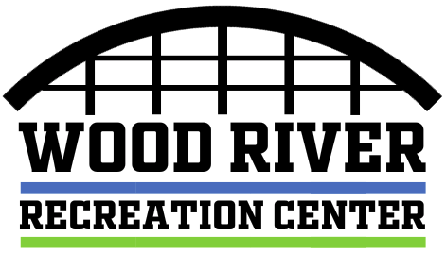
- Experience or education in working with children

For more information email Tyler Lafferty at TLafferty@wrparks.org

